KALAIYARASAN K  Computer Science & Engineering Student   +91 6383833445  kkalaiyarasan21102007@gmail.com  Dharmapuri, Tamil Nadu | 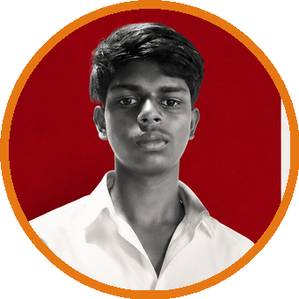
 CAREER OBJECTIVE
To obtain an opportunity where I can apply my technical knowledge, enhance my programming and development skills, and contribute to the growth of the organization while continuously learning emerging technologies.
 PROFESSIONAL SUMMARY
A motivated and enthusiastic Computer Science Engineering student with a strong interest in software development, app development, graphic design, and digital creativity. Passionate about learning new technologies, solving problems, and contributing to innovative projects. Eager to apply technical knowledge and continuously develop professional skills.
 EDUCATION
● Bachelor of Engineering (B.E.) – Computer Science & Engineering (Currently Pursuing)
Anna University
● Higher Secondary Education
Government Higher Secondary School, Solaikkottai
● Middle School Education
Government ADW Middle School, Rajappettai
 TECHNICAL SKILLS
Microsoft Office | App Development | Graphic Design | Image Editing
 LANGUAGES
Tamil | English
 STRENGTHS
Quick learner | Team player | Creative thinking
Good communication | Problem-solving ability | Adaptability

